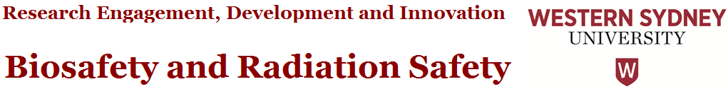
Overarching Principle and Intent
The Biosafety and Radiation Safety Committee (BRSC) deals with a range of matters including those related to genetically modified organisms. The scope of the legislative and compliance matters include the Gene Technology Act and Regulations, as well as the Work Health and Safety legislation.

List of techniques and organisms that are not gene technology

The following information is taken from the Gene Technology Regulations 2001 (as amended 1 September 2011).
The following do not fall under the Gene Technology Regulations and OGTR approval is not required.

Schedule 1A: techniques that are not gene technology
- Somatic cell nuclear transfer, if the transfer does not involve genetically modified material
- Electromagnetic radiation-induced mutagenesis
- Particle radiation-induced mutagenesis
- Chemical-induced mutagenesis
- Fusion of animal cells, or human cells, if the fused cells are unable to form a viable whole animal or human
- Protoplast fusion, including fusion of plant protoplasts
- Embryo rescue
- In vitro fertilisation
- Zygote implantation
- A natural process, if the process does not involve genetically modified material
- Examples of natural processes include conjugation, transduction, transformation and transposon mutagenesis.

Schedule 1: organisms that are not genetically modified organisms
- A mutant organism in which the mutational event did not involve the introduction of any foreign nucleic acid (that is, non-homologous DNA, usually from another species).
- A whole animal, or a human being, modified by the introduction of naked recombinant nucleic acid (such as a DNA vaccine) into its somatic cells, if the introduced nucleic acid is incapable of giving rise to infectious agents.
- Naked plasmid DNA that is incapable of giving rise to infectious agents when introduced into a host cell.
- there is no item 4
- there is no item 5
- An organism that results from the exchange of DNA if:
(a) the donor species is also the host species; and
(b) the vector DNA does not contain any heterologous DNA.
- An organism that results from an exchange of DNA between the donor species and the host species if:
(a) such an exchange can occur by naturally occurring processes; and
(b) the donor species and the host species are micro-organisms that:
(i) satisfy the criteria in AS/NZS 2243.3:2010 for classification as Risk Group 1; and
(ii) are known to exchange nucleic acid by a natural physiological process; and
(c) The vector used in the exchange does not contain heterologous DNA from any organism other than an organism that is involved in the exchange

Related Policies, Procedures & Forms:
Gene Technology Act 2000
Gene Technology Regulations 2001
OGTR Guidelines for the Transport, Storage and Disposal of GMOs
OGTR DNIR application form
OGTR Operational Policies - Scope of variation of GMO licenses
OGTR Guidance for making Records of Assessment of NLRDs

Biosafety and Radiation Safety guidance documents available from REDI

- GMO Dealings
- GMO Project Approval Procedure
- GMO Project Amendment Procedure

Biosafety and Radiation Safety Team Contact: Biosafetyradiation@westernsydney.edu.au
Guidance on Data Storage and Retention Questions in the NEAF

